Open Submission Members Exhibition

Clay/works at the Printworks, Dublin Castle,

18th July – 15th August 2021
in partnership with the Office of Public Works

Please note there will be no official launch this year due to Public Health Guidelines but we will be open to the public from Sunday 18th July

We are looking for up to three/four works from each entrant. Depending on space and scale, and due to having to implement a one way viewing system, not all works from each entrant may be shown but we guarantee to exhibit at least one piece of work. We are delighted to announce that Members will also be in with a chance to win one of 2 (Independently selected) Awards (please note an application is required for the Blue Egg Gallery Bursary).
BURSARY/ AWARDS:
- The 7th Blue Egg Gallery Bursary - €500 - is open for applications- details on the website – Deadline 21st June - the winner will be announced during the show
- Ceramics Ireland Professional Practice Award - €500 is open for applications- details on the website - Deadline 28th June the winner will be announced during the show

The mounting fee is €20 for all paid up Members (those with “2021” on their cards) and this amount, which is non-returnable, must be sent with the entry Form A below.
Please note the commission rate, which will be deducted from all sales is reduced to 30%

While all reasonable precautions will be taken, exhibitors are advised to insure their pieces for the period of the exhibition and transport to and from the exhibition.
Ceramics Ireland is not arranging insurance and it should be noted that neither Ceramics Ireland nor the proprietors of the Printworks, are responsible for losses or breakages etc.

Please note: It is very important to ensure that the ceramics submitted are of a high standard; i.e., no surface defects, including bases. Also, if submitting wall pieces, please note they should be ready for hanging.

DEADLINE FOR FORM A: No later than Friday July 9, 2021
Ceramics may be delivered to the Printworks, on Thursday 15th July between 10am – 2pm. Please do not deliver before that date, as they do not have storage facilities.

Please mark the boxes clearly for the exhibition with the Artist Name. The ceramics must be carefully packed in a cardboard box or plastic crate with a lid - the Price and the Name of the ceramicist on each item. The attached Form B must be completed and included with your boxed work.

DELIVERY: Ceramics may also be delivered by prior arrangement to:
- Helen Costello, Cloughjordan/ Barak Obama Plaza 087 6482395
- Tina Byrne, Wicklow, 085 7190912.
PLEASE RING TO ARRANGE - before Thursday 8th July.
Any entry arriving after Thursday 15th July cannot be accepted.

FORM A
DEADLINE FOR FORM A: No later than Friday 9th July 2021
I WISH TO EXHIBIT AT the Ceramics Ireland Open Submission Members Show – Clay/works at the Printworks, Dublin Castle 18th July – 15th August 2021

NAME: MEMBERSHIP NO:
EMAIL:
PLEASE provide details of your delivery person for security purposes: Name: _____________________________
Or I will deliver in person on Thursday 15th July Please select a preferred time slot for delivery of work to the Printworks - rank these 1-4 in order of preference
(note: each time slot is limited to 15 people – preferred slots will be allocated on a first come first serve basis)
10-11am □ 11-12noon □ 12-1pm □ 1-2pm □

Please complete this Form A in full and return with fee (€20) to: The Secretary, Botanic Gardens, Glasnevin Dublin 9. email: info@ceramicsireland.ie

Cheque/postal order/bank draft should be made payable to: CERAMICS IRELAND

Alternatively the fee can be paid via PayPal on www.ceramicsireland.ie
(If paying online please post/email FORM A to the address above)

CERAMICS IRELAND OPEN SUBMISSION MEMBERS EXHIBITION
Clay/works at the Printworks – 18th July – 15th August 2021
Given the social distancing protocol that we are required to implement it is imperative that we have 2 members invigilating the show at all times, also in order to minimize the risks we would ask that you please consider signing up to help at least one full day over the 4 week run of the Exhibition.

Also, if you can help us, for a few hours for set up or takedown on the dates below, please fill in the section below and return along with FORM A please.

THANK YOU!
I can help for set up/takedown/rota on the following dates, (please tick)
PLEASE Note: when helping /invigilating masks should be worn at all times
Thursday 15th July Between 10am and 4pm – delivery and unpacking of work/plinths □
Friday 16th July Help with plinths/pricelists/signage □
Saturday 17th July Pricing and labelling □
Sunday 18th July Pricing and labelling / Sales desk prep □
Saturday 14th August Packing up Sales for collection 3-5pm □
Sunday 15th August Between 10 - 1pm. Dismantling the exhibition: packing up the unsold pieces for collection by makers / dismantling the plinths /repair and paint walls
Full day on Rota □ Please specify date(s):_____________________________________
From 18th July until 15th August
Please specify the dates that may suit you best - thanks! Rota time slot: full day 10.45 – 5pm
A rota will also be drawn up and circulated asap for the exhibition
OPENING TIMES: Monday to Sunday 11am - 5 pm - 7 Days a week for 4 weeks this equates to 28 days X 2 people required for each day so please sign up to help out where possible.
Anyone interested in helping out please contact info@ceramicsireland.ie

NAME: ____________________________________ TEL: ________________
If you have any further questions please contact Elaine Riordan at 087 9510765

FORM B

OPEN SUBMISSION MEMBERS EXHIBITION
Clay/works at the Printworks, Dublin Castle
18th July – 15th August 2021

MEMBERS NAME: ____________________________________________ Membership Number: _______

NO. | DESCRIPTION | NO. OF PIECES | TITLE (if any) | PRICE incl.30%
- 1

- 2

- 3

- 4

N.B. PLEASE ENCLOSE THIS FORM WITH YOUR BOX OF CERAMICS.

PLEASE PUT THE PRICE AND NAME OF THE CERAMICIST ON THE BASE OF EACH ITEM SUBMITTED, INCLUDING EACH ITEM IN A SET ALSO WRITE YOUR NAME ON YOUR BOX/CRATE

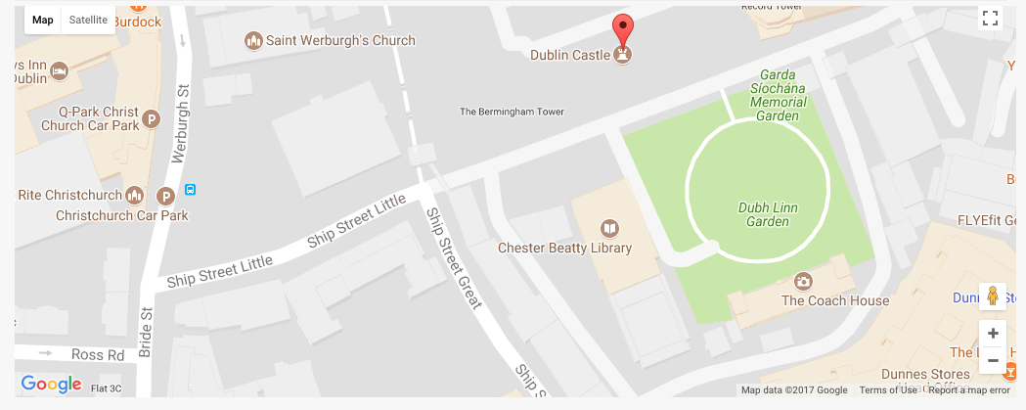
Thursday 15th July
Between 10am and 2pm – for delivery of work for the show
Please select a time slot (note: each time slot is limited to 15 people – preferred slots will be allocated on a first come first serve basis)

10-11am □ 11-12noon □ 12-1pm □ 1-2pm □

Deliveries should be made via the Ship Street Little Entrance just explain to the Security man that you are dropping ceramics to the Printworks for the Ceramics Ireland Exhibition, he will explain that you are to proceed to the barrier near the Printworks and how to enter so that you can pull up outside the Gallery space.
PLEASE NOTE that NO parking is available onsite and if you are staying to help you may need to pre-book the nearby multi-story carpark at Christchurch.

Application Checklist:
- Fill in and submit Form A with fee by Friday 9th July
- Sign up to help with rota and/or setup and take down
- Label all work with your Name, title (if applicable) and price.
- Fill in Form B and pack with your work
- Pack work well in a strong box/ crate with a lid and label clearly with your name
- Arrange delivery for Thursday 15th July between 10am – 2pm.

