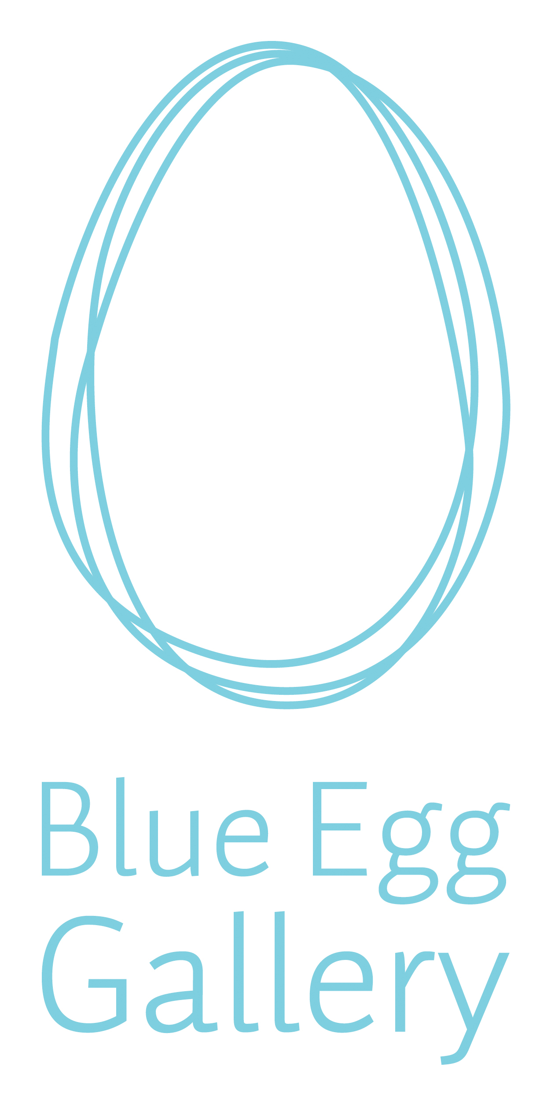

Blue Egg Gallery Bursary 2022

Ceramics Ireland is delighted to invite applications for the Eight Blue Egg Gallery Bursary. Applications are open to members of Ceramics Ireland and we invite you to send your applications before Monday July 9th. The award winner will be announced at the opening reception for the Open Submission Members Exhibition Clay/Works at The Printworks, Dublin Castle on July 30th, 2022.

Value €500
The Blue Egg Bursary is a substantial award and has the potential to make a positive impact on your practice. In your application let us know how the bursary will impact your practice in real terms, be precise about how for example materials / a new piece of equipment will help you develop / enhance your work or make life in the studio easier. Rather than saying it would be great to get some new clay to experiment with, tells us what the plans are for the new clay, and why you should be selected to receive the bursary.

Purpose: To assist a potter/ceramic artist with the development of their practice by funding initiatives such as:
- The purchase of equipment
- Experimentation with new glazes
- Attendance at courses & workshops to enhance their skills

Applications: Please complete the attached Application form and email it to info@ceramicsireland.ie along with a copy of your CV and artist statement and 4 photos of recent work – photos must be individually named and numbered eg: Mary Higgins 1 / Mary Higgins 2

The Award winner will be announced at the opening reception for the Open Submission Members Exhibition Clay/Works at The Printworks, Dublin Castle on July 30th, 2022 and online on our website ceramicsireland.ie and on our social media platforms during run of the exhibition. The exhibition runs until August 27th.

Eligibility: Open to all 2022 members of Ceramics Ireland
Adjudication: A three-person panel including Mary Gallagher

Deadline:
Closing date for receipt of applications is 9th July 2022.

Name:
Email:

What is the reason for your application? (50 words or less)

What difference would winning the bursary make to your practice? (200 words or less)

